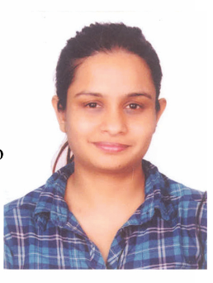
Present Address:11 Mhada C wing flat : 1906 Virat nagar, Virar
Mumbai 401303
Name: Kanchan Chawhan
Email : kaanncy@gmail.com
Contact: 9322230678

SUMMARY

To be a part of organization where the management structures recognize and reward loyalty, hard work and ambition of employee by providing growth opportunity.

PROFESSIONAL EXPERIENCE

- Worked with Dr. Batra’s as a senior customer support executive (BPO) from July 2021 till current March 21, 2022
Job Profile

- Inbound and Outbound calling process in dialer
- Sales and achieving targets.
- Lead generation to evaluate business
- Bookings to ensure patient visit clinic, follow ups
- Prospective leads which get Registered.
- Handling customer complaint, query

- Worked with Medlife as a customer support executive( BPO) from September
2020 to January 2021
Job Profile
- Inbound and Outbound calling process in dialer.
- Handling customer complaint, query
- Sales and achieving targets.
- Lead generation to evaluate business

- Worked With Metabolic Restoration Therapy pvt. ltd. from 26th June 2016 to August 2018
Job Profile
- Handling all Admin related work & accounts.
- Making cold outbound calls for sales lead generation
- Communicating in mail with Clients Solving Quires of Client Satisfactory
- Managing Staff related Queries
- Handling Company Events making flight & hotel booking arrangement.

- Worked with Truebil.com from 28th April 2015 to 25th June 2016
Job Profile
- Handling inbound and outbound calls and fixing appointment
- Communicating with field Team Providing client leads by fixing
Appointment for car Inspection.
- Achieving Target of Team on behalf of team members
- Maintaining Price Data by convincing Client to reduce car price as per Market Price.
- In CVR software and Online Sheets

- S-Team Tranzact Consulting Pvt Ltd as Loan Executive from September 2013 to March 2015.
Job Profile
- Handling walking clients and giving them information about loan.
- Maintaining details of the customer reports.
- Coordinating with clients in terms of deals of loan procedure.
- Visiting places of customer for document.
- Maintaining MIS for the same & documentation.

HOBBIES
- Listening soft music.
- Interacting with people.
- Sharing knowledge and visiting a new place.
- STRENGTHS
- Warm smile.
- Ambitious.
- Self confidence, Keen learner and positive attitude toward the task.
- Willing to work comfortably as team member.

ACADEMIC QUALIFICATION

SSC. 2nd​ ​ Class 2003. Pass
HSC. 2​ ^{nd} ​ Class 2007 Pass

PERSONAL DETAIL

Date of Birth Birth Place | : 12th​ September, 1989​  : Delhi
Father’s Name | : Vasant P Chawhan
Sex | : Female
Marital Status | : Married
Language known | : English, Hindi, Gujarati , Marathi
Nationality | : Indian

Place: Mumbai ​(Kanchan Chawhan)​

